**Containers**

**Group Box:**

A Group Box control is a container control that is used to place Windows Forms child controls in a group. The purpose of a Group Box is to define user interfaces where we can categories related controls in a group.

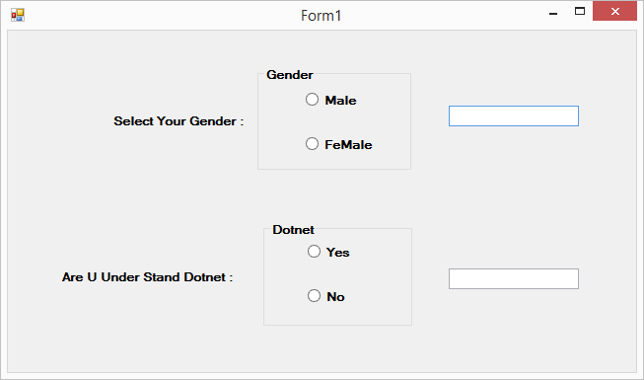

using System;

using System.Collections.Generic;

using System.ComponentModel;

using System.Data;

using System.Drawing;

using System.Linq;

using System.Text;

using System.Threading.Tasks;

using System.Windows.Forms;

namespace WindowsFormsApplication_Day4

{

public partial class Form1 : Form

{

public Form1()

{

InitializeComponent();

}

private void radioButton1_CheckedChanged(object sender, EventArgs e)

{

if (radioButton1.Checked == true)

{

textBox1.Text = radioButton1.Text;

}

}

private void radioButton2_CheckedChanged(object sender, EventArgs e)

{

if (radioButton2.Checked == true)

{

textBox1.Text = radioButton2.Text;

}

}

private void radioButton3_CheckedChanged(object sender, EventArgs e)

{

if(radioButton3.Checked==true)

{

textBox2.Text = radioButton3.Text;

}

}

private void radioButton4_CheckedChanged(object sender, EventArgs e)

{

if(radioButton4.Checked==true)

{

textBox2.Text = radioButton4.Text;

}

}

}

}

**Panel**

The Panel Control is a container control to host a group of similar child controls. One of the major uses I have found for a Panel Control is when you need to show and hide a group of controls. Instead of show and hide individual controls, you can simply hide and show a single Panel and all child controls.

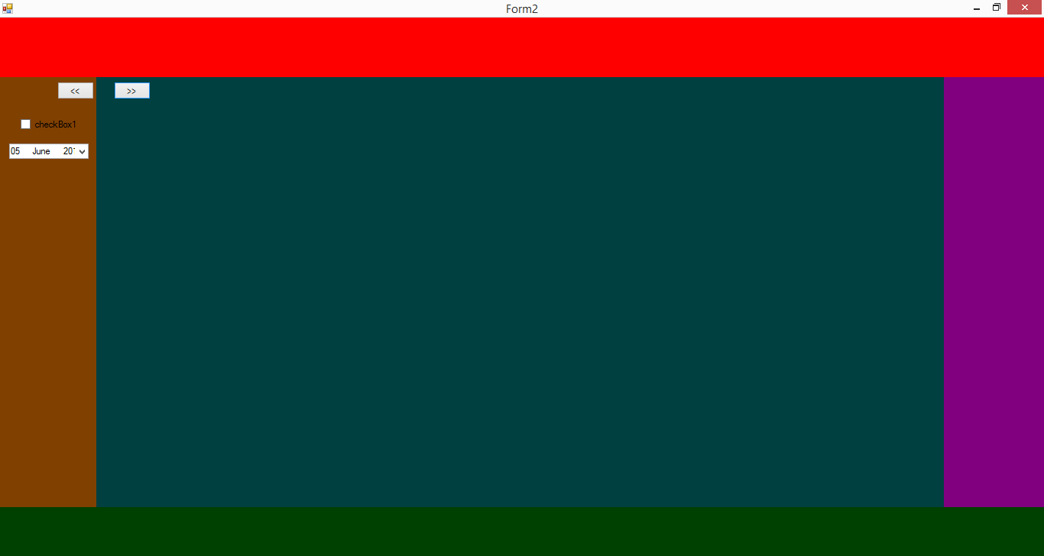

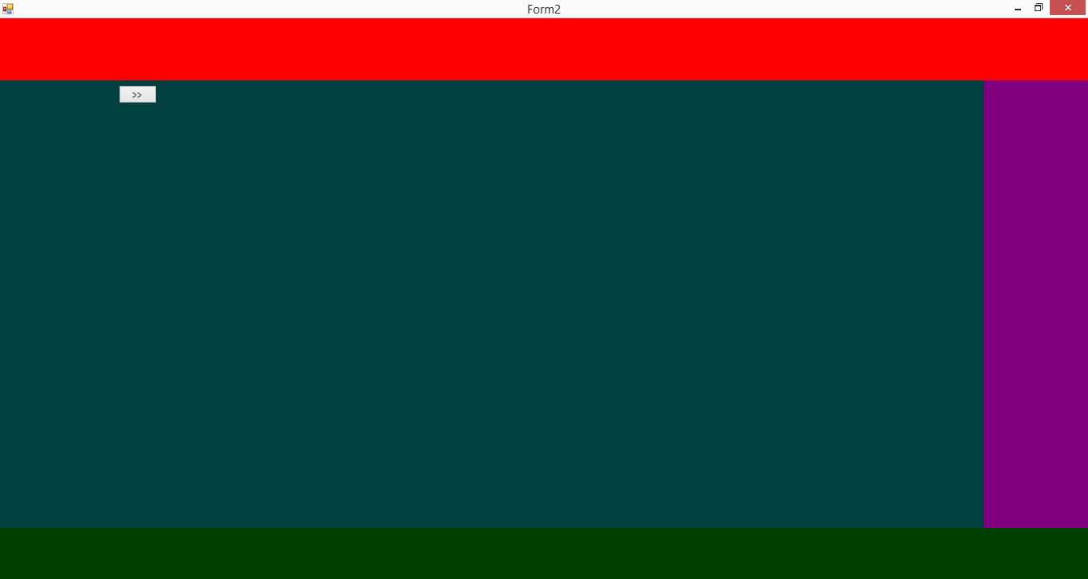

using System;

using System.Collections.Generic;

using System.ComponentModel;

using System.Data;

using System.Drawing;

using System.Linq;

using System.Text;

using System.Threading.Tasks;

using System.Windows.Forms;

namespace WindowsFormsApplication_Day4

{

public partial class Form2 : Form

{

public Form2()

{

InitializeComponent();

}

private void button1_Click(object sender, EventArgs e)

{

panel3.Visible = false;

}

private void button2_Click(object sender, EventArgs e)

{

panel3.Visible = true;

}

}

}

**Flow layout panel**

The Flow Layout Panel control is a container control that provides dynamically layout for the child controls that can be arranged horizontally or vertically. The flow direction of the control sets the direction of arrangements of controls.

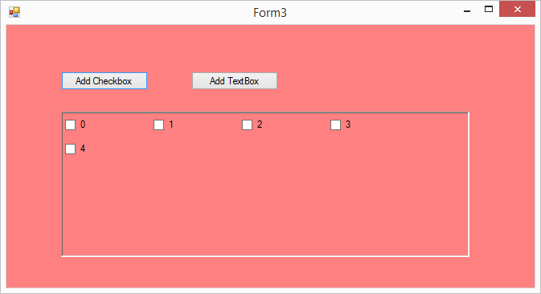

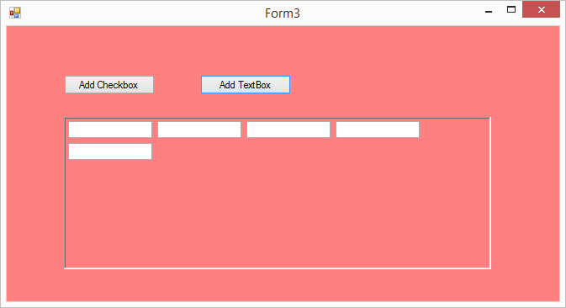

using System;

using System.Collections.Generic;

using System.ComponentModel;

using System.Data;

using System.Drawing;

using System.Linq;

using System.Text;

using System.Threading.Tasks;

using System.Windows.Forms;

namespace WindowsFormsApplication_Day4

{

public partial class Form3 : Form

{

// varibles

CheckBox[] chk;

TextBox[] txtbox;

public Form3()

{

InitializeComponent();

}

private void button1_Click(object sender, EventArgs e)

{

// add Check boxs

chk = new CheckBox[5];

for(int i=0;i<5;i++)

{

chk[i] = new CheckBox();

chk[i].Name = i.ToString();

chk[i].Text = i.ToString();

chk[i].TabIndex = i;

chk[i].AutoCheck = true;

flowLayoutPanel1.Controls.Add(chk[i]);

}

}

private void button2_Click(object sender, EventArgs e)

{

// add Textboxs

txtbox = new TextBox[5];

for(int i=0;i<5;i++)

{

txtbox[i] = new TextBox();

txtbox[i].Name = i.ToString();

txtbox[i].TabIndex = i;

flowLayoutPanel1.Controls.Add(txtbox[i]);

}

}

}

}

**Tab control**

A Tab Control is used to manages and display the user related collection of tab pages in tab pages the user can design the with different controls

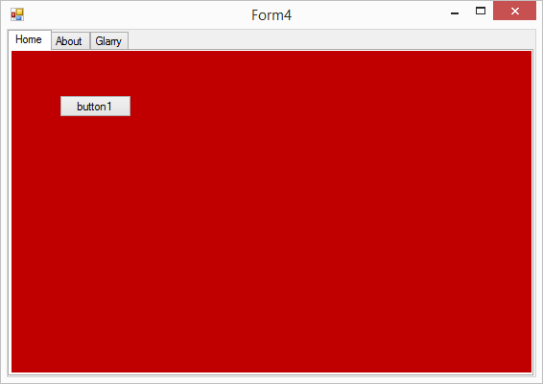

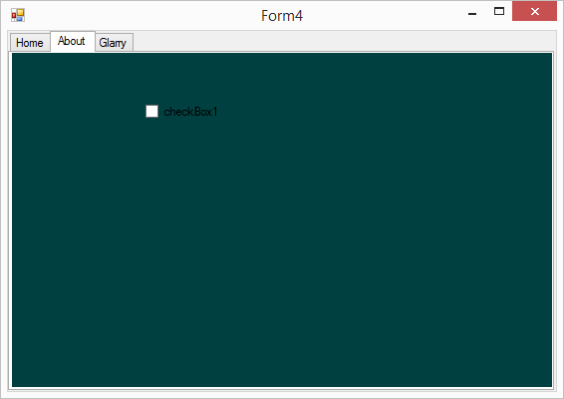

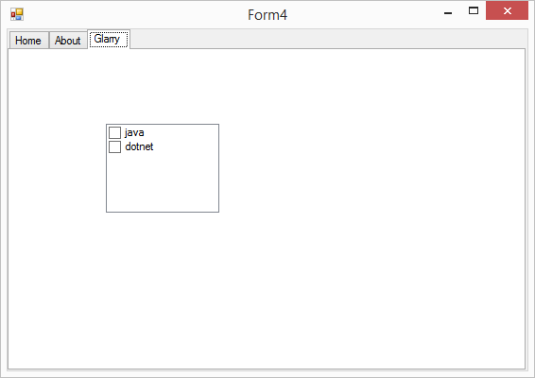

**Menus**

**Menu Strip**

Menu Strip adds a menu bar to your Windows Forms program. With this control, we add a menu area and then add the default menus or create custom menus

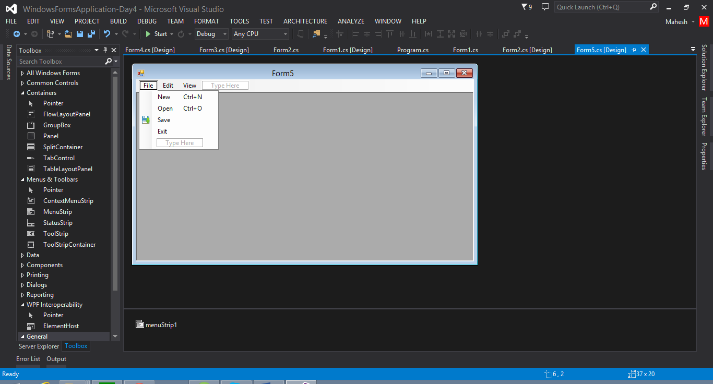

**Status Strip**

Status Strip control is used to show a variety of status message in a status area in a form. This status strip control can use the themes provided combined with buttons and progress bar to show state and operation progress.

**Tool Strip**

The tool strip is provides toolbars and other user interfaces element that support many appearance options and that supports overflow run-time item reordering.

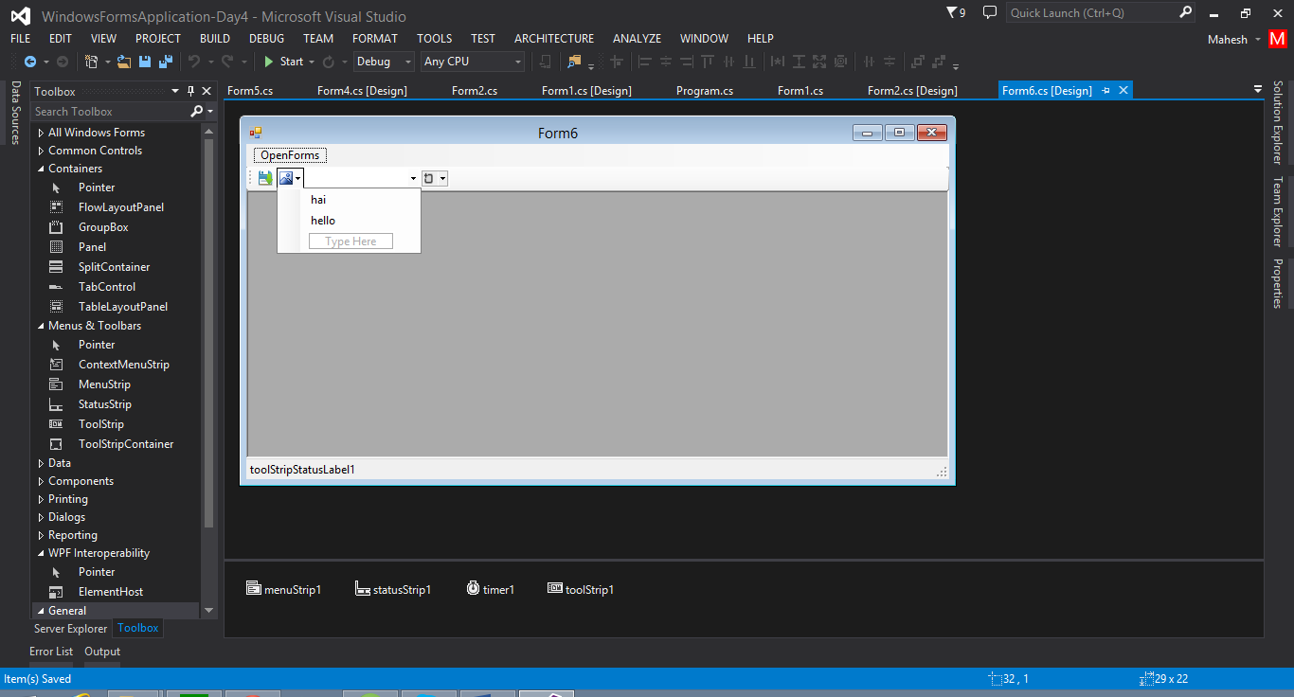

using System;

using System.Collections.Generic;

using System.ComponentModel;

using System.Data;

using System.Drawing;

using System.Linq;

using System.Text;

using System.Threading.Tasks;

using System.Windows.Forms;

namespace WindowsFormsApplication_Day4

{

public partial class Form6 : Form

{

public Form6()

{

InitializeComponent();

}

private void form1ToolStripMenuItem1_Click(object sender, EventArgs e)

{

Form1 obj = new Form1();

obj.MdiParent = this;

obj.WindowState = FormWindowState.Maximized;

obj.Show();

}

private void form2ToolStripMenuItem_Click(object sender, EventArgs e)

{

Form2 obj = new Form2();

obj.MdiParent = this;

obj.WindowState = FormWindowState.Maximized;

obj.Show();

}

private void form3ToolStripMenuItem_Click(object sender, EventArgs e)

{

Form3 obj = new Form3();

obj.MdiParent = this;

obj.WindowState = FormWindowState.Maximized;

obj.Show();

}

private void form4ToolStripMenuItem_Click(object sender, EventArgs e)

{

Form4 obj = new Form4();

obj.MdiParent = this;

obj.WindowState = FormWindowState.Maximized;

obj.Show();

}

private void form5ToolStripMenuItem_Click(object sender, EventArgs e)

{

Form5 obj = new Form5();

obj.MdiParent = this;

obj.WindowState = FormWindowState.Maximized;

obj.Show();

}

private void Form6_Load(object sender, EventArgs e)

{

}

private void timer1_Tick(object sender, EventArgs e)

{

toolStripStatusLabel1.Text = DateTime.Now.ToString();

}

}

}

**Context Menu Strip**

The Context Menu strip is used to display the short cut menu when the user right –click the associated control

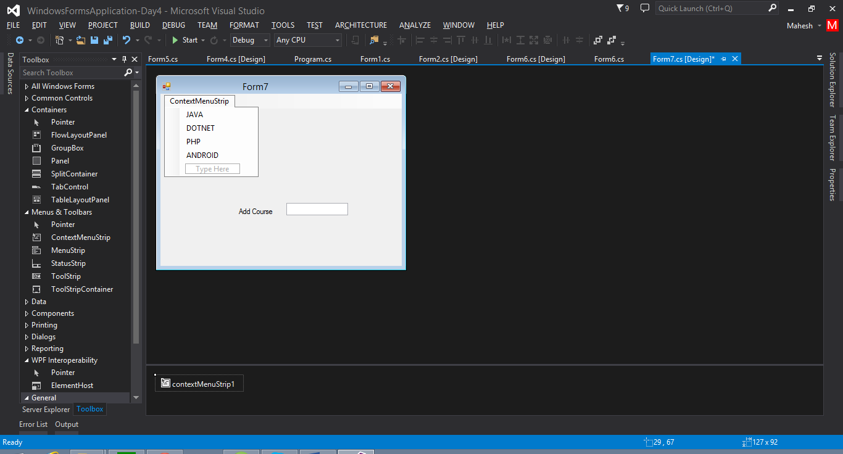

Go to textbox properties select context menu strip

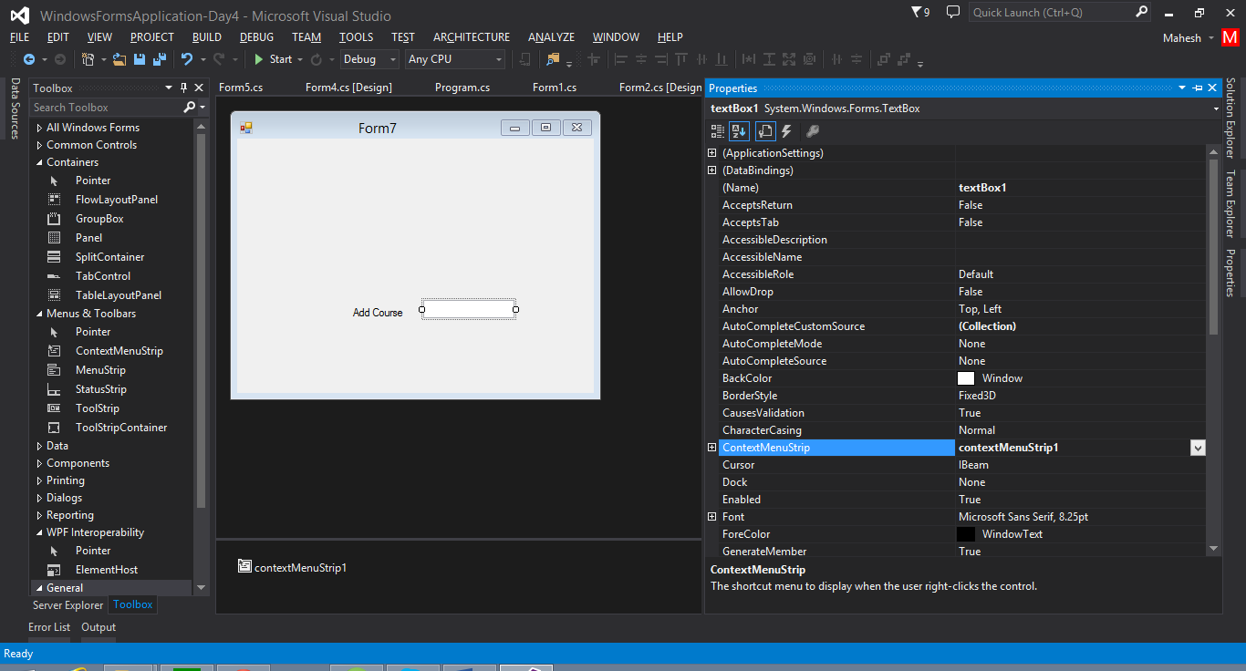

using System;

using System.Collections.Generic;

using System.ComponentModel;

using System.Data;

using System.Drawing;

using System.Linq;

using System.Text;

using System.Threading.Tasks;

using System.Windows.Forms;

namespace WindowsFormsApplication_Day4

{

public partial class Form7 : Form

{

public Form7()

{

InitializeComponent();

}

private void jAVAToolStripMenuItem_Click(object sender, EventArgs e)

{

textBox1.Text = jAVAToolStripMenuItem.Text;

}

private void sOTNETToolStripMenuItem_Click(object sender, EventArgs e)

{

textBox1.Text = "DotNet";

}

private void pHPToolStripMenuItem_Click(object sender, EventArgs e)

{

textBox1.Text = pHPToolStripMenuItem.Text;

}

}

}